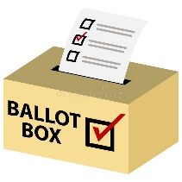**2024 MSFPOA Election**

**FAILED**

Folks, the election failed. It was cancelled because

There were no candidates. No one nominated anyone,

nor did anyone volunteer. Nothing has changed.

It was reported & discussed in the BOD meeting this past summer.

Anyone wanting more details should read the meeting minutes

on the website or contact the office and ask for them to be emailed.

If you would like to serve on the Board, please let the office know ASAP.

*The current Board cannot serve forever…ANYBODY???*